IMMUNIZATION
Code : IMS 1202
Hours: 24
Credits : 2
By: Gladys k

WELCOMING NOTE
Welcome to this course on immunization.
This course is all about immunization being a global programme for the control of vaccine preventable diseases among children and people of all ages.
This course is very relevant for you as an health care worker since you will be required to conduct immunizations in various health facilities.
In Kenya, the Expanded Programme on Immunization (EPI) was launched in 1980 with the main aim of providing immunization against six killer diseases of childhood, namely tuberculosis, polio, diphtheria, whooping cough, tetanus and measles to all children in the country before their first birthday, and tetanus toxoid vaccination to all pregnant women.
Prior to 1980 vaccination services had been provided on an ad-hoc basis mainly through primary schools and the larger health institutions. The programme has introduced into the infant immunization programme new vaccines notably; vaccines against hepatitis B virus and the hemophilus influenza type b bacteria in 2002, the ten valent pneumococcal conjugate vaccine in 2011.

Although the programme has not achieved optimal coverage in a number of districts, the overall impact of the programme has been a tremendous reduction in key vaccine preventable diseases, notably the elimination of diphtheria, the near elimination of pertusis, near eradication of poliomyelitis, marked reduction of diseases caused by the hemophilus influenza type b bacteria, and marked control of measles.
Learning support
The learner is free to ask for support in understanding the content from the lecturer through 0727220602. This should be done during working hours in weekdays.

Assignments.
This will be communicated to the learners before it is administered. This includes how it will be done and submitted back to the lecturer for marking
Course learning requirements
All learners shall be required to do their assignments and submit on time as stated.
Self assessment tests.
At the end of every topic, the learner is encouraged to assess him/herself to determine whether they have understood the content.

ABBREVIATIONS

AD Auto-disable
BCG Bacille Calmette – Guerin vaccine
DVI Division of Vaccine & Immunization
EPI Expanded Program on Immunisation
IPV Inactivated polio vaccine
KEPI Kenya Expanded Program on Immunization
MCH/FP PHC Mother and Child Health/Family Planning and Public Health Care
MMR Measles/Mumps/Rubella vaccine
OPV Oral polio vaccine
TT Tetanus toxoid
UNICEF United Nations
VVM Vaccine vial monitor

WHO World Health Organization
Learning out comes
By the end of this course, the learner should be able to;
- Define some common terms applied in immunization
- Describe the EPI concept
- Describe the KEPI policy issues
- Describe the KEPI immunization schedule
- Explain how the cold chain system operates
- Explain what is involved in preparation of vaccination services
- Explain the community mobilization and involvement process
- Describe the prevention of various immunizable diseases
- Describe the travel medicine immunization process

DEFINITION OF TERMS
Immunity: the ability of the body to resist harmful disease organisms.
Antigen: is any substance which is capable, under appropriate conditions, of inducing a specific immune response. Antigens may be soluble substances, such as toxins and foreign proteins, or particulate, such as bacteria and tissue cells.
Antibody: Antibody is a special protein (immunoglobulin) found in tissue fluid and blood serum. It is produced in response to specific antigen for protection against specific antigen.
Prophylaxis: the administration of drugs or vaccines for prevention and not for curative purposes.
Natural immunity: When organisms invade the body, the white blood cells called lymphocytes identify the organisms or products referred to as the antigen. The body then produces antibodies to fight the antigens. This is referred to as natural immunity.
Artificial immunity: This is the type of immunity given through vaccine administration. A vaccine will stimulate a protective immune response that will prevent disease in the vaccinated person if he gets into contact with the corresponding infectious agent
VACCINES
Vaccine: A vaccine is made of an organism or a toxin which is either killed or attenuated.

Attenuated: reduced power of virulence of micro-organisms - deprived them of their pathogenic properties without killing them, or inactivating their antigenicity properties. This means it is harmless. However, its antigenicity will be identified by lymphocytes and this will induce the production of antibodies.

Passive immunity: this is when one is protected temporarily by use of “borrowed” antibodies. It is common especially to newborn babies who utilize antibodies from their mother’s immune system in the early months of life before they process their own.
Heard immunity: This develops when a high proportion of the community, 80% or more, have been immunized. A protective effect is developed for the few who have not been immunized in this community.

Cold chain is a process of maintaining vaccines in a potent state from the manufacturer to the recipient (child and woman of child bearing age)
Missed opportunity A missed opportunity for immunisation occurs when any eligible child or woman comes to a health facility and does not receive any or all of the vaccine doses for which he or she is eligible

Introduction
The immunization program is a global programme for the control of vaccine
preventable diseases among children and people of all ages. In the Global Vaccine Action Plan
(GVAP) of 2012, the global programme has set ambitious goals of eradicating and certification
of a poliomyelitis free world by 2018, by 2020 Measles and rubella eliminated in at least 5 WHO
regions, reach 90% national coverage and 80% in every district or equivalent administration for
all vaccines in national programmes, and by 2020, the licensure and launch of vaccine or vaccines against one or more major diseases.
In Kenya, the Expanded Programme on Immunization (EPI) was launched in 1980 with the main aim of providing immunization against six killer diseases of childhood, namely tuberculosis,polio, diphtheria, whooping cough, tetanus and measles to all children in the country before their first birthday, and tetanus toxoid vaccination to all pregnant women.

Developments in immunizations in kenya
- Introduction of 2nd measles vaccine in 2013
- Introduction of Rota Virus vaccine in 2014
- OVP trivalent to bivalent in 2016
- Measles Rubella in 2016
- PCV 10 ( 2 dose to 4 dose vial formulation) in April 2019
- Yellow Fever Vaccine expansion in May 2019(Elgeiyo Marakwet, Baringo, West Pokot and Turkana )
- MEN A in June 2019 ( meningitis A)
- Malaria in 8 endemic counties in September 2019 ( 6, 7, 9 and 24 months respectively) :- Kisumu, Homabay, Vihiga, Busia, Kakamega, Siaya, Migori And Bungoma
- National HPV In October 2019
- Soon there will be a switch from TT to TD Targeting 10 years old

Immunization System Components
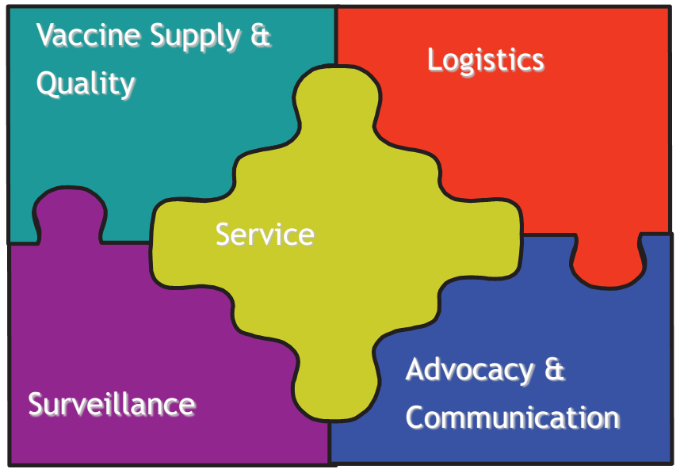

The immunization system components include ;
- Service delivery,
- Vaccine supply,
- Quality,
- Logistics,
- Disease surveillance and advocacy,
- Communication and
- Social mobilization.

The Components of KEPI
1. Integration
Integration of KEPI with maternal and child health services was done from the outset.

2. Training
The objective aimed at improving the knowledge and skills of health workers. Training was to be done at senior, supervisory and operational levels.

3. Social Mobilisation
Social mobilisation is one of the most important activities of the programme. To achieve the KEPI objectives, we need to convince families to bring children for immunisation so as to increase community involvement and participation.

4. Disease Surveillance
Surveillance is the collection and analysis of data for action. This is done through routine reporting, sentinel reporting and surveys.
5. Cold Chain System
The cold chain is a system of keeping vaccine cold and in a potent state from the manufacturers’ level until it is administered to a child or a pregnant woman. A break in the cold chain system will render vaccines useless.

6. Monitoring and Evaluation
Monitoring and evaluation of all aspects of the programme at all levels are designed as on-going functions.

7. Logistics and Supplies
This includes vaccines, child health cards, reporting forms, cold chain equipment, transport, gas, syringes, needles, etc. The health workers should maintain the equipment to prolong its use.

8. Supervision
Meaningful supervision at district levels to be carried out by use of “checklists” and feedbacks provided.

Kenya’s Policy on Immunisation
Each country has an immunisation policy, which usually follows the general guidelines developed by WHO. These policies enable a country to standardise immunisation procedures and practices. The policy in Kenya is to:
Integrate immunisation activities into the MCH/FP PHC framework.
Use one sterile syringe and needle per injection to prevent cross – infection.
Use potent a vaccines kept at 2⁰C to 8⁰C.

Maintain cold chain at all times – monitor the refrigerators, twice in the day, that is, morning and evening, and keep vaccines on reconditioned ice packs during vaccination sessions.
Discard all opened vaccines, especially the live attenuated vaccines such as measles, BCG within 4 – 6 hours after opening.
Offer daily immunisation from 8 am – 5 pm at fixed posts and supplement that by outreach services
AIMS OF EPI
1. Immunisation of at least 95% of all children fully before the age of 1 year
2. Eradication of poliomyelitis
3. Eradication of Neonatal tetanus
4. Control of measles.

Objectives of UVI
To ensure equitable access to appropriate vaccination services for all persons in Kenya
• To ensure universal immunization of children in Kenya with appropriate doses of Ministry of
Health prescribed childhood vaccines.
• To ensure universal immunization of special risk groups with Ministry of Health approved
priority vaccines
• To ensure optimum vaccination service delivery in response to specific situations of outbreak
of life threatening vaccine- preventable diseases

Priorities of immunization
- Polio eradication
- Accelerated disease control
- Improving performance of routine Immunization
- Supplemental Immunization
- Improving financial flows
- Creating demand of immunization services through evidence-driven advocacy
- Improving the capacity of health workers

General norms and guiding principles for programme implementation
- Community participation and social mobilization
- Integrated approach- immunization services should be provided as an integral part of national family health programmes
- Accessibility and equity
- Provided to all target populations irrespective of ethnicity, gender or political and religious affiliation.
- Quality of services and safety consideration
- coordination and leadership
- Regulatory issues relating to immunization
- Most countries in the African region do not manufacture vaccines hence:

Service delivery strategies and innovative approaches
1. Immunization at static health facilities (fixed strategy)
2. Immunization delivery through outreach services: An outreach clinic is where you take MCH services and curative services from a health facility to the community within the catchment area and return back to the health facility the same day.
Cont…
3. A mobile clinic is taking MCH services to a community, lasting for more than one day without returning to the health facility.
4. Immunization campaigns or supplementary immunization activities
5. supplementary immunization

SUPPLEMENTARY IMMUNUIZATION FOR MEASLES ELIMINATION
- Catch up campaign- one dose for all children between 9 months to 14 years is given , regardless of vaccination or disease history.
- Follow- up- campaign –one dose of measles vaccine to children born since the catch –up campaign

- Mopping up- where poor coverage was achieved in the catch-up or follow-up campaign, or when epidemiology evidence suggests measles transmission is focalized.
- Periodic intensification of routine immunization (PIRI)- reinforces routine immunization and uses a second opportunity to immunize susceptible persons remaining in the population and those never vaccinated
Vaccinology and the expanded programme of immunization
Immunity: : the ability of the body to resist harmful disease organisms.
It is the ability of the human body to tolerate the presence of materials indigenous to the body (self), and to eliminate foreign materials
Immunity to a microbe is usually indicated by the presence of antibody to that organism
Immunity is generally specific to a particular organism or group of closely related organisms.

Natural History of Infection
The first phase in the natural history of an infection is the progression from a healthy state to a disease state. This is marked by the entry and multiplication of infectious agent in the host.
Until typical signs and symptoms of the disease appear, the patient remains in a sub-clinical state.

The interaction between the pathogen or the pathogen’s toxin and the body could result in disease. This phase is marked by the appearance of typical signs and symptoms of the disease. The interval between exposure to an infectious agent and onset of clinical disease is called the incubation period.

The outcome of the infection depends on how well the body handles the pathogen or the toxin.
This phase is marked by either a full recover, recovery with disability or death

Types of immunity
- Natural immunity; -active
-artificial

- Passive immunity: ; -active
-artificial
1.Natural Active Immunity
This is the immunity acquired after an individual has survived an infection with the disease causing form of the organism.
The patient will not get ill again hence he/she is said to have acquired natural immunity. For example, if a child has had measles and recovered, the child’s lymphocytes produce antibodies any time the child encounters the measles virus throughout the child’s life.

Artificial Active Immunity
This is the type of immunity given through vaccine administration.
For example if a child gets the oral polio vaccine (attenuated live polio virus), the child’s body will produce antibodies against poliovirus and hence will be protected against poliomyelitis without having been sick.
Natural Passive Immunity
Passed immunity from the mother to the baby.
The transfer of antibodies from mother to foetus across the placenta
during the last 2-3 months of pregnancy provides the newborn with a portion of the mother’s immunological experience.
Eg tetanus and measles acquired from the mother
Artificial Passive Immunity
Borrowed” antibodies can also protect one temporarily. These borrowed and prepared antibodies
are from serum (antiserum) of person or animal that has been exposed to an antigen and has
produced antibodies which are purified and are directly injected to the person at the site of
infection to immediately counteract the offending antigen. Sources of passive artificial immunity
include blood and blood products, immune or hyper-immune globulin, and animal antitoxins.
Herd Immunity
This is the protective effect accorded to the few individuals who have not been immunized in a community that has a high proportion of immunized population.
There are two ways of developing herd immunity:
High natural infection rate in the community.
• Artificial immunization.
Types of Vaccines used in by the Kenya UVIS
There are three types of vaccine:
• Live attenuated vaccines
• Inactivated vaccines – either whole cell or cell fractions
• Genetically engineered ( recombinant) vaccines – which are similar to inactivated vaccines

- Live attenuated vaccines
Live attenuated vaccines are derived from disease-causing viruses or bacteria that have been weakened under laboratory conditions.
Cont..
They will multiply in a vaccinated individual, but because
they are weak, either cause no disease or only a mild form. Usually, only one dose of this type of vaccine provides life-long immunity, with the exception of oral polio vaccine, which requires multiple doses.
Examples of live attenuated vaccines include:
• Virus: oral polio vaccine (OPV), measles, yellow fever
• Bacteria: BCG, oral typhoid (Salmonella typhi) and oral cholera
- Inactivated vaccines
Inactivated vaccines are produced by growing viruses or bacteria and then inactivating them with heat or chemicals. Because they are not alive, they cannot grow in a vaccinated individual and therefore cannot cause the disease.
Since they are not as effective as live vaccines, multiple doses are required for full protection.
Booster doses are needed to maintain immunity because protection by these vaccines diminishes over time.
Examples of inactivated vaccines
Smallpox, Injectable Polio Vaccine (IPV) (Salk), hepatitis A, Influenza, rabies
whole-cell pertussis, inactivated cholera, anthrax
Diphtheria and tetanus toxoids, Haemophilus influenzae type b conjugate vaccine
(Hib), pneumococcal conjugate vaccine (PCV)
Hepatitis B, HPV
Summary of types of vaccines
1. Mono-vaccines measles
2. Combined or polyvalent DPT
3. Bacterial vaccine – vaccines against cholera pertussis
4. viral vaccines – OPV and vaccines against measles , mumps rubella ,yellow fever
5. Liquid vaccines: DPT, Polio vaccines
6. Lyophilized (dry) vaccines: BCG, Measles

CHARACTERISTICS OF IDEAL VACCINES
1. Immunogenic provoking a good immune response
2. Providing long lasting immunity
3. Safe with no or very rare AEFIs
4. Stable in field conditions and can be stored reasonably long without or with a very minimum cold chain requirements
5. Combined ,with several antigens producing immunity against a number of diseases
6. Administered with a single dose ,preferably by non-injectable routes (oral or through inhalation)
7. With affordable cost and accessible to all.

Summary of the immunization schedule

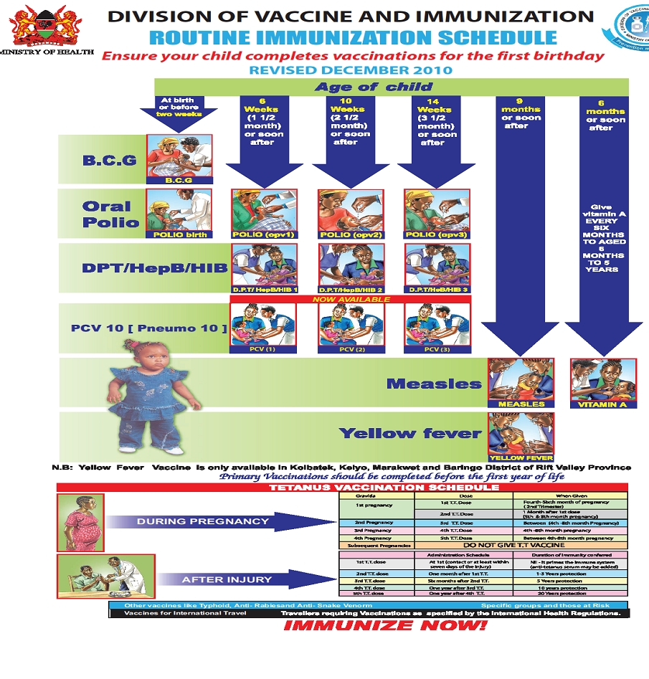

AGE OF CHILD | VACCINE | DOSAGE | ROUTE
At birth or before two weeks | B.C.G.  Birth polio | 0.05mls (under1year) intradermal  0.1 mls (over 1 year) | Intradermal  Intradermal
At6 weeks (1 ½ month) or soon after | Polio (OPV1)  DPT, Hep B,HIB.  *(Pentavalent) 1,  rota virus 1 | 2 drops oral  0.5 mls intramuscular | Oral  Intramuscular.  oral
At 10weeks(2½ months or soon after | Polio (OPV 2)  DPT, Hep B, HIB.  *(Pentavalent) 2  Rota virus 2 | 2 drops oral  0.5 mls intramuscular | Oral  Intramuscular  oral
At 14weeks (3½months) or soon after | Polio (OPV 3)  DPT, Hep B,HIB  *(Pentavalent) 3  IPV | 2 drops oral  0.5 mls intramuscular  0.5 mls intramuscular | Oral  Intramuscular  intramuscular
At 9 months or soon after | Measles  Yellow fever | 0.5 mls subcutaneous  0.5 mls subcutaneous | Subcutaneous
At 6 months or soon after | Vitamin A | 1,000,000 IV oral | Oral
Give vitamin A every six months from 6 months to 5 years | Vitamin A | 2,000,000 IV | Oral
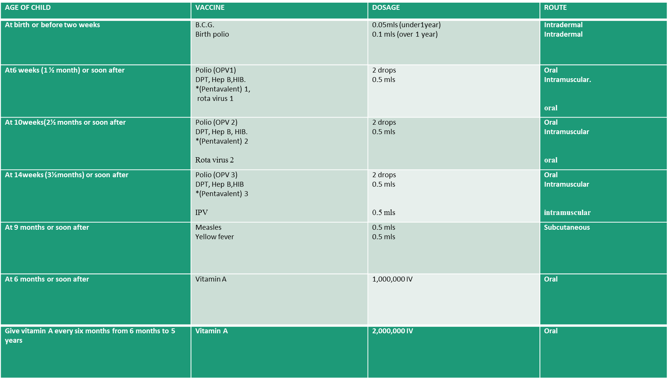
Summary of the immunization schedule

The National Childhood Immunisation Schedule.

IMMUNIZATION SERVICE DELIVERY AND VACCINE ADMINISTRATION
General guidelines for vaccine administration

vaccines
A vaccine typically contains an agent that resembles a disease-causing microorganism, and is often made from weakened (inactivated) or killed (dead) forms of the microbe or its toxins.
Scientists take several approaches to develop vaccines against a microbe. The choice is based on fundamental information about the microbe, such as:
- How it infects cells
- How the immune system responds to it,
- As well as practical considerations, such as regions of the world where the vaccine would be used.

1. BCG (Bacillus Calmette-Guerin) Vaccine
This is a live attenuated bacterial vaccine that is usually freeze-dried. protective against infant tuberculous meningitis and miliary tuberculosis, and remains an important tool for the prevention of tuberculosis.
- It is named after two French scientists, Dr Calmette and Dr Guerin
- It should be stored in a regular refrigerator (not in the freezing compartment)
- it can remain potent for up to two years.
- Once it has been diluted, the vaccine loses its potency very quickly and must be discarded after six hours (6HOURS)
- BCG vaccine is given in a single dose at birth or first contact.
- The vaccine is very sensitive to light and loses much of its potency when exposed to light.
- It is given by injecting the child intradermally (in the skin) at the left upper arm.
- When administered subcutaneously, lymphadenitis can occur, with rare instances of suppuration and fistulae formation. Other severe reactions include injection site abscesses or severe ulcerations;
- The amount of 0.05mls is recommended for children up to eleven months of age,
- Dose of 0.1 ml for children after eleven months of age.

Steps to follow when administering BCG vaccine
- Clean the skin with dry cotton wool soaked in clean water and let it dry.
- Hold the middle of the child's upper right arm firmly with your left hand.
- Hold the syringe by the barrel with the millilitre scale upward and the needle pointing in the direction of the child's shoulder.
- Do not touch the plunger.
- Point the needle against the skin, barrel turned up, about 3cm above your thumb.
- Gently insert its tip into the upper layer of the skin.
- Make sure that the needle is in the skin (intradermal) and not under the skin,
- If you bend the needle, replace it with another sterile one.
- Holding the barrel with your index and middle finger, put your thumb on the plunger.
- Holding the syringe flat, that is, parallel to the surface of the skin,
- inject the vaccine intradermally.
- For children above 11 months of age, inject 0.1 ml.
- For children under 11 months of age, inject 0.05 ml.
- If the vaccine is injected correctly into the skin, a wheal, with the surface pitted like an orange peel, will appear at the injection site. An indication that the vaccine has been injected incorrectly is that the plunger will move much more easily when the needle is injected under the skin than when it is injected in the skin.
- If there is no local reaction, re-immunise the child.
- Change the syringe and needle after each antigen (vaccine) and each child.
- Fill in the Immunization Tally Sheet in BCG section.
- Administer the next antigen.

GIVE THE MOTHER HEALTH INFORMATION ABOUT BCG
- In 5 to 7 days a small sore will appear at the place where the injection was given.
- The sore might ooze a bit and will last for 6 to 8 weeks.
- Keep the baby's arm clean with soap and water.
- Do not put medicine or dressing on the sore.
- The sore will not hurt, and it will heal by itself.

PREPARING FOR BCG & MEASLES VACCINES
- Use the diluent provided for each vaccine. Diluent should be cold: +4 - +8 degrees centigrade.
- Use different 5ml syringes for mixing measles and BCG vaccines.
- Draw up the full, required amount of the diluent provided as per instruction on the vial.
- Inject diluent into vial.
- Draw and expel mixture back into the bottle three times or until the vaccine is mixed.

- Do not shake the vial.
- Measles and BCG vials should be placed on a frozen ice pack or use the sponge in the vaccine carrier for maintaining the correct temperature.
- Draw 0.5ml of measles vaccine (recommended dosage).
- Draw 0.05ml of BCG vaccine for babies up to 11 months old, and 0.1ml for babies above 11 months (recommended dosage)

2. ORAL POLIO VACCINE (OPV)
The oral polio vaccine contains live attenuated virus from all three types of polio.

TYPES OF POLIO VACCINE
- Monovalent polio vaccine -against only one strain of polio virus(either type 1 or type 2 poliovirus)
- Bivalent polio vaccine, a new double strain polio vaccine, is more effective than triple and single strain vaccines and could play a major role in polio eradication
- Trivalent-a polio vaccine :that targets all the three subtypes of poliovirus.
- Inactivated oral polio vaccine

The Sabin type is given orally (by mouth) in Kenya. Some countries use another type, called Salk vaccine, which is given by injection.
Oral polio vaccine is given four times beginning at birth
Two drops in the mouth are recommended for each dose.
It should be noted that booster doses are sometimes given to all children below five years of age in the entire country regardless of immunisation status.
This is done during National Immunisation Days (NIDs), whose primary objective is to eradicate poliomyelitis.

POLIO IMMUNIZATION SCHEDULE
Polio 0: Birth or first contact
Polio 1: 6 weeks
Polio 2: 10 weeks
Polio 3: 14 weeks

Preparing Polio Vaccine
To prepare this vaccine you should do the following.
- If a dropper is separate, attach it securely to the vial (bottle).
- Keep polio vaccine shaded from sunlight during the immunisation session.
- Place the vial on a frozen ice pack or place it in the hole of the sponge placed at the mouth of a vaccine carrier, which is provided for this purpose to maintain the temperature
3. PENTAVALENT
- This is the newly introduced combination of immunisation against diphtheria, pertussis (whooping cough), tetanus, hepatitis B and influenza.
- The dose is 0.5ml.
- The first dose is given six weeks after birth, the 2nd at ten weeks after birth and 3rd at the age of 14 weeks
- Pentavalent has five vaccines which include diphtheria, pertussis, tetanus, and hepatitis B and Haemophilus influenza type B.
- The Pentavalent vaccine is given by injecting the child intramuscularly (in the muscle) at the left upper thigh.
- It is given three times, beginning at 6 weeks), at 10 weeks and 14 weeks respectively.
- A dose of 0.5 ml is recommended at each time it is given.

HEALTH TALK TO THE MOTHER ON DPT/PENTAVALENT
1. DPT may cause some tenderness at the place the injection was given.
2. This tenderness will go away after a few days.
3. DPT may cause fever but the fever will subside in 24 hours.
4. Teach the mother how to care for a child with fever.
5. Fill in the Immunisation Tally Sheet appropriately
Preparing pentavalent, TT, IPV and PCV vaccines:
These vaccines come in liquid form. You will not need to dissolve or mix them.
- Remove metal top from the vial
- Draw 0.5ml into the sterile syringe
- Remove bubbles
- Keep the vaccines shaded from light.

4. MEASLES VACCINES
- Its a live attenuated freeze-dried vaccine given at nine months old and a second dose at 18 months.
- It is administered by intramuscular injection (on the right deltoid.)
- in a dose of 0.5ml.
- An oral vitamin A tablet, 200,000 i.u., is routinely given with the measles vaccine.

Failure of Measles Vaccination
It has been noted that some children still suffer from measles in spite of the fact that they were vaccinated.
The possible causes of this may be:
1. Impotent measles vaccine may have been used
2. The vaccine may have expired or may have been kept at the wrong temperature
3. The child may have been vaccinated while still too young thus having their mother’s antibodies still in their blood
4. The parents may have misreported some rashes and pyrexia, which appear similar to measles yet it is not

CONTRA-INDICATION OF MEASLES
In severe malnutrition, it is recommended that the vaccination be delayed until the child is well nourished.
In mild or moderate malnutrition, it should still be administered.

ROTA VACCINE

- Rotavirus is a virus that is acquired via fecal-oral route and causes severe diarrhea mostly in babies and young children.
- It is often accompanied by vomiting and fever.
- Rotavirus is non-enveloped, composed of a segmented, double-stranded RNA genome
- Cont…
- It is a pentavalent human-bovine reassortant vaccine that is given orally
- It was previously a reassortant rhesus-human rotavirus vaccine tetravalent (RRV-TV) but was withdrawn from the market in July 1999 by the CDC, after approximately 1 million children had been immunized with the vaccine and there was an increase in the number of children who developed intussusception

DOSES
- Children should get 3 doses of rotavirus vaccine.
- They are recommended at these ages:
- First Dose: 6weeks
- Second Dose: 10 weeks

- The vaccine has not been studied when started among children outside that age range.
- Rotavirus vaccine may be given at the same time as other childhood vaccines.
- Children who get the vaccine may be fed normally afterward
EFFICACY
- Its efficacy was evaluated in two large clinical trials. After three doses the vaccine was 74% effective against rotavirus gastroenteritis of any severity and 98% effective against severe rotavirus gastroenteritis.
- In another study, the vaccine reduced the incidence of office visits by 86%, emergency room visits by 94% and hospitalizations for rotavirus gastroenteritis by 96%.

SIDE EFFECT
- Children are slightly (1-3%) more likely to have mild, temporary diarrhea or vomiting within 7 days after getting a dose of rotavirus vaccine than children who have not gotten the vaccine.
- No moderate or severe reactions have been associated with this vaccine.

CONTRA-INDICATIONS
1. A child who has had a life-threatening allergic reaction to a previous dose or a component of the vaccine should not get another dose.
2. immune-compromised patients:
3. There is no safety information related to the administration of vaccine to infants with gastroenteritis. It is recommended that rotavirus vaccine not be administered to infants with acute, moderate-to-severe gastroenteritis
4. A child who has recently had a blood transfusion or received any other blood product (such as immune globulin).

OTHER VACCINES
. Rabies vaccine
Rabies vaccine is given to people at high risk to protect them if they are exposed. The vaccine is made from killed rabies virus and is administered intramuscularly.
Pre-exposure vaccination is in three doses:
Dose 1: as appropriate
Dose 2: 7 days after 1st dose
Dose 3: 21 or 28 days after 1st dose
Vaccination after exposure to the virus is given in 4 doses; day 0, 3, 7,14 and 90

2.Typhoid vaccine
There are two types of the typhoid vaccine. One is an inactivated (killed) vaccine gotten as an injection
The live attenuated vaccine which is taken orally.
given as a single dose intramuscularly.
A booster is given every 2-3 years especially to people who remain at risk.

3.Yellow fever vaccine
Yellow fever vaccine is a live attenuated virus.
It is given as a single dose, For people who remain at risk,
a booster dose is recommended every ten years.
Can be given to persons from 9 months to 59 years who are travelling to or living in an area where the risk of yellow fever is known to exist.

Key messages to remember
- Never take two vials of the same vaccine out of the vaccine carrier at the same time.
- Do not mix vaccines until mothers and children are present.
- Mix one vial of a particular vaccine at a time
- Keep opened vials of polio, measles, and BCG vaccines on a frozen ice pack or use the sponge in the vaccine carrier. Their temperature must be carefully maintained.
- Do not keep vials of pentavalent and TT vaccines directly on the frozen ice pack.
- Open the vaccine carrier only when necessary.
- Use one sterile syringe and needle per vaccine per child or mother.
- Avoid holding loaded syringes in your hands for long so as not to expose vaccine to heat or direct sunlight.
- Inform each parent what type of vaccine you are giving the child, the possible reactions to it, what to do about the reactions, and when to bring the child back for more immunisation.
- Listen to parents and encourage questions.
- Remove any child’s clothes that are in your way when vaccinating

During immunisation you should:
1. Ask the mother to hold the child firmly to restrict his/her movement during immunisation.
2. Administer the vaccine.
3. Give specific health information about each vaccine

Take Note
In Kenya Yellow fever vaccine is given only in Koibatek, Keiyo, Marakwet and Baringo Districts of Rift Valley Province.

Primary vaccinations should be completed before the first year of life.

Pentavalent is a terminology that is used to refer to the combined vaccine for DPT, Hepatitis B and HIB.

STRATEGIES FOR ERADICATION OF CHILDHOOD IMMUNISABLE DISEASES.
1. Strengthening of routine immunization activities to achieve and maintain the highest levels of coverage for all antigens.
2. Mass vaccination of children within the shortest possible time through National Immunization Days (NIDS)
3. Strengthening EPI target disease surveillance system such that every case of any of these diseases is reported, fully investigated and contacts of positive cases protected.
4. Conducting "mopping-up" immunisation when the diseases are reduced to focal transmission.

COLD CHAIN
OBJECTIVES
1.Define the cold chain system.
2. List the cold chain equipment used in the country.
3. Demonstrate packing of vaccines in the cold chain equipment.
4. Describe basic principles of refrigeration.
5. Discuss equipment installation procedure.
6. Monitor cold chain temperature.
7. Carry out preventive maintenance activities.
8. Conduct basic fault finding procedure and remedial action.
9. Be able to order spare parts.
10. Be able to take equipment inventory.
11. Know common cold chain emergencies.

COLD CHAIN
What do you understand by the term cold chain? Write a carefully thought out answer and then read the content below to compare your answer.

DEFINITION
Cold chain is a process of maintaining vaccines in a potent state from the manufacturer to the recipient (child and woman of child bearing age)

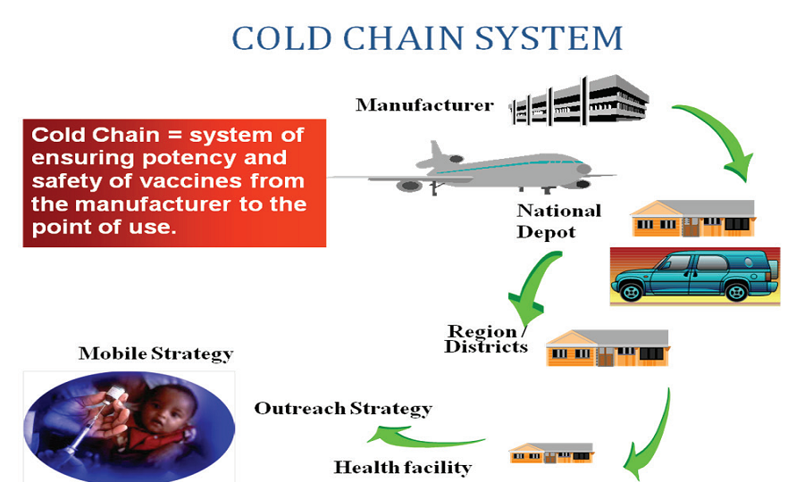
An efficient cold chain system requires trained and skilled staff, reliable equipment and adherence to set standards.
Vaccine Delivery System

Vaccine Delivery System

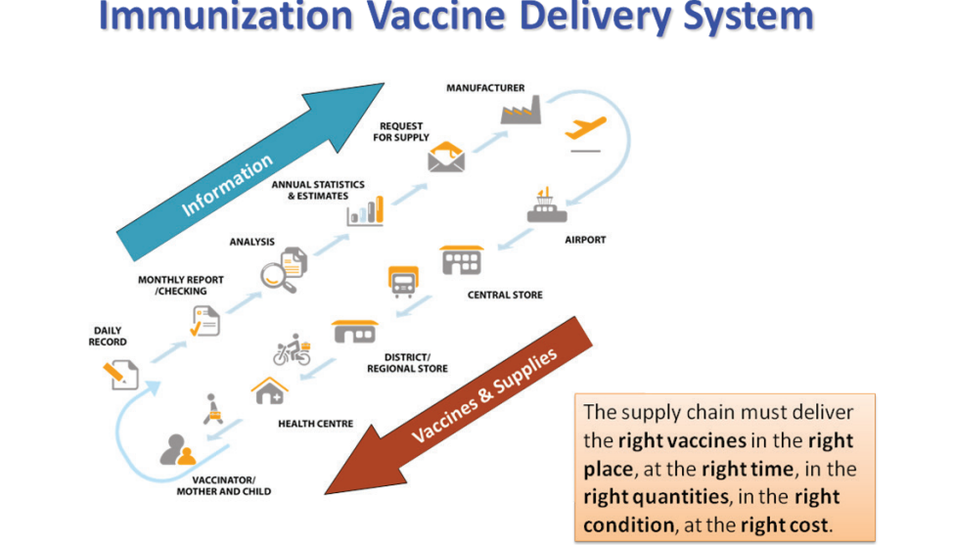

COLD CHAIN EQUIPMENT
Must meet standards set by WHO and UNICEF for safe vaccine storage.

COLD CHAIN EQUIPMENT

Must meet standards set by WHO and UNICEF for safe vaccine storage
1. Cold rooms and freezer rooms
2. Freezers and Ice-lined refrigerators
3. Gas electric refrigerators
4. Solar Refrigerators
5. Vaccine carriers
6. Cold boxes
7. Icepacks
8. Thermometers

Cold rooms and freezer rooms
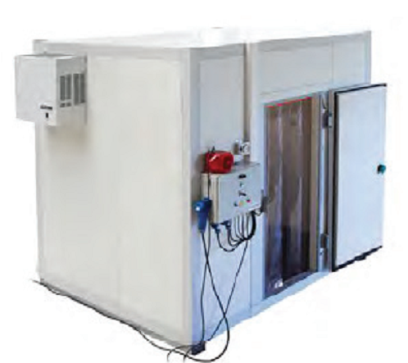

These are large rooms, specially constructed for storage of large quantities of vaccines. They have two cooling units; one running while the other is standby, a 24-hour temperature monitoring
system with an alarm, a recorder, and a backup generator that will turn on automatically when
the regular power is interrupted. Cold rooms are found at the national and regional levels while
freezer rooms are only found at the national level.
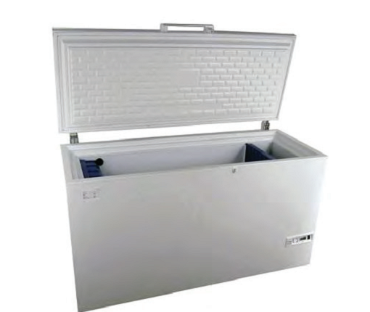
Freezers: Freezers and ice-lined refrigerators are used at Central, Regional& District stores

Ice-lined refrigerators

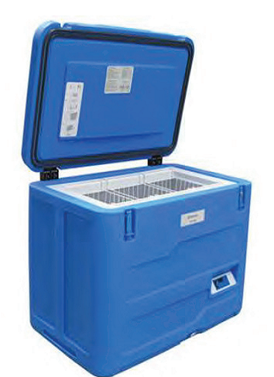

Vaccine Storage Conditions

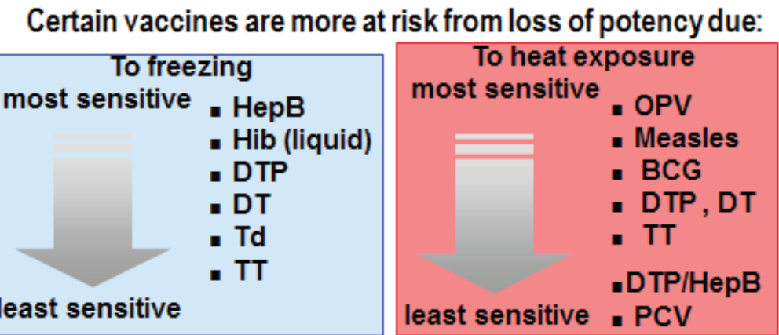

GAS ELECTRIC REFRIGERATOR
The refrigerator is designed for use at the service delivery point. It is operated either on electricity or gas and has top opening door. Trays of different colors are used to store each type of vaccine.
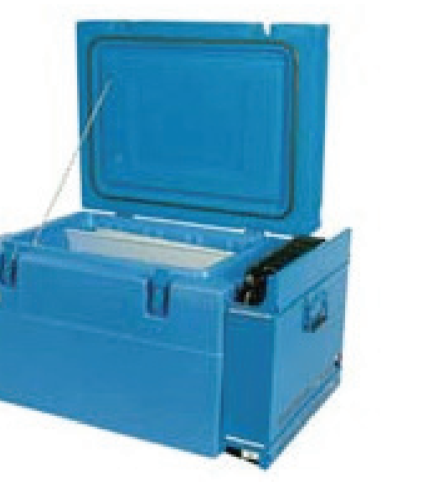

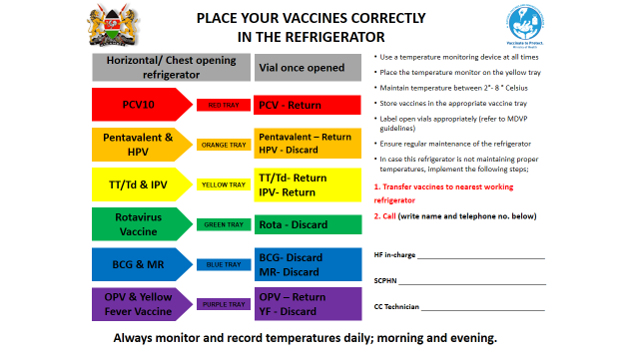

COLD BOX
Used for transportation of vaccines

Vaccine carriers
Used to carry vaccines to service delvery points. The cold life of vaccines is 8 hours

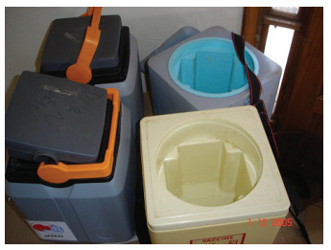

Types of refrigeration systems used in EPI
1. Compression system
- Absorption system
compression type: This type of refrigeration system uses a compressor, which when connected to electricity pumps the refrigerant through the pipes. The pipes connect the inside of the refrigerator to the outside. As the refrigerant circulates, it absorbs heat from inside lowering the
temperature inside the refrigerator. The refrigerator hums when in operation. An example of this refrigerator is TCW 1152

Absorption type: This type of refrigerator has a heating unit, which uses either gas or electricity.
When the heating unit is supplied with a source of heat the refrigerant boils, evaporates and circulates through the coiled pipes where it loses heat changing into liquid as it enters the pipe inside the refrigerator. Due to the low boiling properties of the refrigerant it evaporates again as it enters the inside pipes and this results into cooling. Absorption refrigerator is quiet when in operation. Eg RCW 42 EG

Refrigerator Parts (front & inside)
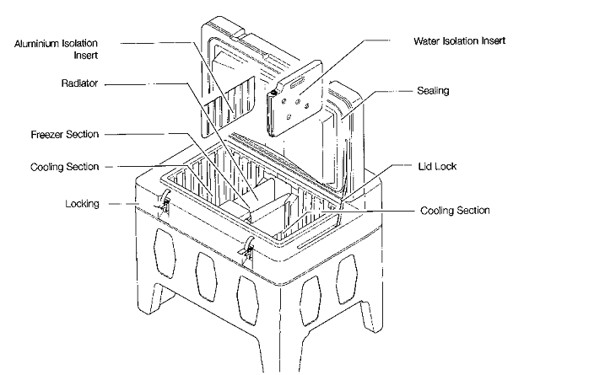

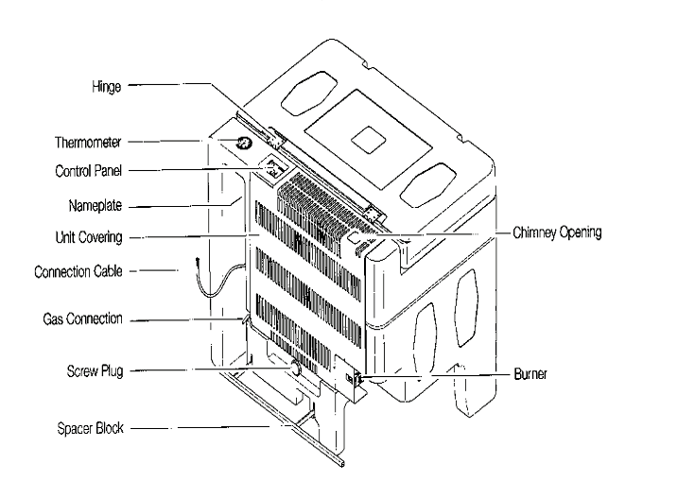
The backside of a refrigerator

A typical cold chain system

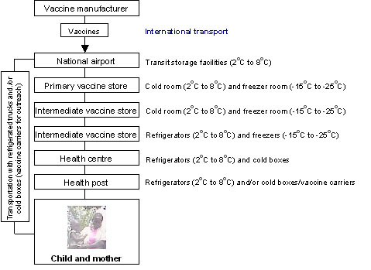

PREVENTIVE MAINTENANCE ACTIVITIES
Daily activities
Check temperature twice, in the morning and evening including public holidays and weekends and chart on the temperature-monitoring chart. Ensure the temperature is between +2°C to +8°C.
• Check that the refrigerator is operating and the burner flame is blue for gas refrigerator.
• Make sure that there is enough gas in the cylinder
• Ensure that vaccines are well arranged in the refrigerator
• do not keep any other item in refrigerator apart from vaccines and diluents.
• Keep a spare gas cylinder available and always replace the gas cylinder before it is completely empty.
Weekly activity
- Check the ice formation on the evaporator. If the ice is thicker than 6mm to 10mm defrost the refrigerator.
- Check that the refrigerator is level.
Monthly activity
• Check that the condenser and cooling unit are clean. Remove any dirt or dust with a soft brush or cloth
When necessary, clean inside and outside of the refrigerator with a damp cloth.
• Clean door gasket and powder it with perfume free talcum.
• Check the gas connections for leaks
yearly
Clean the gas burner and gas jet
Clean the flue and baffle

COLD CHAIN EMERGENCIES
Some of the common cold chain emergencies include:
• Equipment breakdown.
• Electric power failure.
• Shortage of gas.
• Shortage of spare parts.
caution
Use only one power source
Emergency plan
Transferred vaccines need to be captured in the ledger books
Monitoring of the Cold Chain System

What measures do you need to implement so as to maintain the cold chain system? List them down and explain them. Then compare your answers to the discussion below.

Temperature Recording
This is done twice daily, in the morning and in the afternoon. This is important since any failure in the functioning of the refrigerator will be noticed and immediate action taken.
Cold Chain Monitor Cards (3m)
This is a special rectangular card with 4 oral windows with a “stabilizing strip” at the end. The monitor has a heat sensitive indicator in the form of strip with 4 windows stuck to it. This indicator operates at temperatures of 10⁰C and above 34⁰C. It detects cumulative heat exposure above the stated temperatures.

Vaccine Vial Monitor (VVM)
A vaccine vial monitor (VVM) is a label made of heat – sensitive material that is placed on a vaccine vial to register cumulative heat exposure over time. The combined effects of time and temperature cause the monitor to change colour gradually and irreversibly.

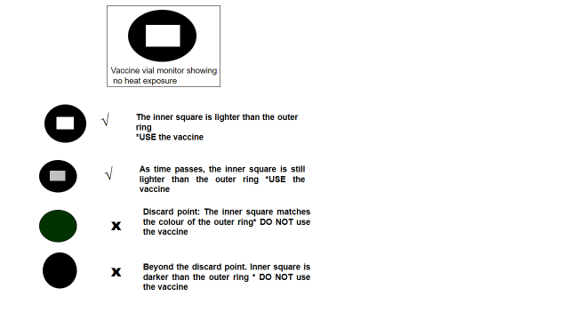

The Freeze Watch Indicator
The freeze watch indicator tells you when the vaccine has been exposed to freezing temperatures. It is useful in detecting vaccines such as DPT, TT, HEP B that should not be frozen. If these vaccines have been frozen, they must not be used as they will have lost their potency

Shake Test
This is a simple test that can be easily done at every stage of the cold chain and is used mostly in testing TT vaccines. The sedimentation rate of a suspect vial is compared with a similar Tetanus Toxoid vial that is known to have been stored at the correct temperature. Shake the two vials vigorously and inspect carefully in strong light.

General Rules for Storing Vaccines in a Refrigerator
The coldest part of the refrigerator is the freezing compartment. It is used to store ice packs for freezing. Never store DPT/ HEP B, TT in the freezing compartment. They lose their potency at very low (freezing) temperature.
The lower part of the refrigerator keeps the temperature low but does not freeze the vaccines. This is where you should keep both vaccines and diluents.
Do not keep any vaccines on the door shelves or on the bottom shelf. Always use the oldest vaccine first. This is known as the “first in, first out” principle (FIFO).
The refrigerator must be level, at least 12 inches away from the wall, to allow free air circulation. Place the refrigerator away from direct sunlight.

 | Answer the following questions:  - What is cold chain?  - Name the elements of an effective cold chain system.  - State the appropriate environmental conditions for each vaccine.  - How do you monitor that the cold chain does not break at any stage?  - List the mandatory requirements for a health facility that offers vaccination services.

ADVERSE EVENTS FOLLOWING IMMUNIZATIONS (AEFI)
INTRODUCTION
The goal of immunization in Kenya is to protect the public from vaccine preventable diseases.
Modern vaccines are safe; although after immunization, some people may experience reactions;
ranging from mild local reactions to life-threatening illnesses.

Broad objective
To assist health workers improve their knowledge, skills and knowledge towards AEFI.
Specific Objectives:
1. Define AEFI
2. Outline how to identify AEFI
3. State the possible causes of AEFIs.
4. Describe how to detect and report AEFI
5. State the steps involved in investigating adverse events.
6. Outline the steps taken in managing AEFI cases.
7. Describe how to prevent cases of AEFI.

DEFINITION OF AEFIs
An adverse event following immunization is a medical incident that that occurs during or after an immunization and is believed to be caused by immunization.

CAUSES
1. Programmatic errors: Usually they are person based i.e. an error in handling, reconstitution or administration of the vaccine.
2. Nature of the vaccine (vaccine properties) or individual response to the vaccine itself.

3. Coincidental, is an event that has no causal association between the immunization and the medical condition of the child or woman.
4. Unknown cause. The cause of the event cannot be determined.

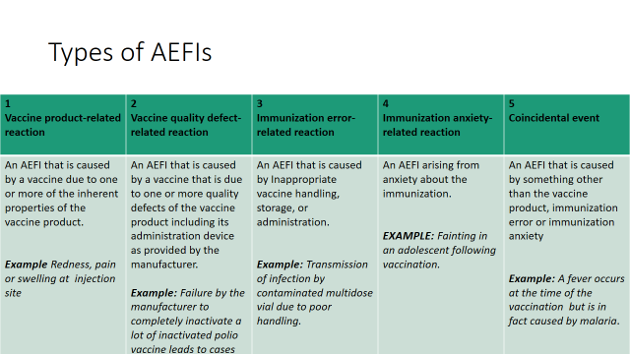

What to do if an AEFI occurs
- First manage patient as per presentation, refer as appropriate
  - Take into consideration coincidental illnesses
- Reassure the caregivers as treatment is being given
- Report on reporting form and send to sub-county public health nurse/Officer/SCMOH
- Record in Tally Sheet and Summary Sheet

- Serious AEFI (death/hospitalization/life-threatening) and AEFI that are linked to immunization errors will need further investigation
- In case of Serious AEFI let the caregiver know that AEFI will be investigated to establish the cause

How to identify AEFI
The cardinal signs of anaphylaxis are:
• Itchy, urticarial rash (in over 90% of cases)
• Progressive, painless swelling (angioedema) about the face and the mouth, which may be preceded by itchiness, tearing, nasal congestion or facial flushing

Respiratory symptoms, including sneezing, coughing, wheezing, and laboured breathing; upper way swelling (indicated by hoarseness and/of difficulty swallowing) possibly causing airway obstruction
• Hypotension, which generally develops later in the illness and can progress to cause shock and collapse.
It must be differentiated from fainting, anxiety and breath holding which are more common and benign reactions.

Contraindications to immunization
• Before immunization, ascertain client history for allergies and previous adverse reactions to vaccines.
In the case of a possible serious allergy, check with the appropriate supervisor before giving vaccine.
• This procedure will minimize the occurrence of anaphylaxis but will not remove the risk altogether.

• Low-grade fever, mild respiratory infections and other minor illnesses should not be considered as contraindications to immunization. Diarrhoea should not be considered a contraindication to OPV. It is particularly important to immunize children suffering from malnutrition.

VACCINES MANAGEMENT
The effectiveness and success of KEPI in reducing the burden of immunization preventable diseases depends on the quality of vaccines at the point of use, which in turns reflects the usefulness of the vaccine management system.

In order to reduce mortality, morbidity and disability, immunization session must safely administer potent vaccines to susceptible children and women before they are exposed to immunization preventable diseases.

The immunization programme aims at resolving vaccine and management problems which includes:
1. Reduction of the incidences of overstocking or under stocking of vaccines
2. Ensuring proper accountability for all vaccines at all levels
3. Reduction of vaccine wastages

TARGET SETTING
What do you understand by the term immunisation target population? What about catchment area? See the content below for the answser.
Each Sub-county is expected to set targets for two population categories
• Children less than 1year
• Women of child bearing age

VACCINES FORECASTING
In order to accurately estimate the vaccines, reliable data must be collected from the health facilities to the districts. Having set the target number of children to be vaccinated in the new-year, each health facility should forecast the number of doses of vaccines required to reach all the target children and childbearing age women.

Advantages of obtaining accurate forecasting of vaccine needs
1. It leads to efficient management of vaccines and immunization sessions
2. It eliminates shortages or overstocking of vaccines
3. It improves vaccine use and reduction of wastages
4. It helps to monitor the progress of immunization in relation to target coverage

The three methods commonly used to estimate vaccine needs:
1. Target population
2. Previous consumption
3. Size of immunization sessions
All facilities are required to estimate vaccine needs using the target population method and if the Health facilities are sharing the same population, previous consumption method would be suitable.

1. Target Population Method
Target population is the number of children under one year and women of childbearing age (15- 49 years old).
To estimate vaccine needs on the basis of target population a number of parameters are necessary, which are:
a. Target population

b. Immunization schedule
c. Immunization coverage target
d. Wastage rate and wastage factor

 | Determine the target population in the following communities.  - Keruko community with a total population of 24,000,  - Bondeni community with a population of 42,000,  - Kinondoni community with a population of 88,000,  - Kijiji ndogo community with a total population of 164,000

Immunization coverage target
The national policy is to reach every child. The Immunization coverage target for each antigen depends on the health facility and district micro plans and work plans respectively. These plans indicate the attainable percentage coverage at the end of current year.

 | 1. Kanze community has a population of 88,000 people.  - Determine the immunization target population  - Determine how many doses were administered if the coverage that year was estimated at 72%  2. Sangaa community had a population of 104,000 people.  a) Determine the immunisation target population  b) If only 67600 doses were administered during the year, determine the  immunisation coverage percentage  - If the targeted national level of coverage is 85% what is the  community coverage failure rate.

Vaccine wastage rate and wastage factor
During immunization, the number of vaccine doses used is generally higher than the number of individuals immunized. The number of doses in excess represents “lost doses “or vaccine wastage.
These may include:
  - The remainder of doses discarded with vials after the immunization session
  - Doses given outside the target

  - Doses spoilt for one reason or the other e.g. VVM reached discard point, breakdown in the cold chain, frozen DTP+ HepB and TT or removed labels.
  - Doses from vials broken during transport and handling
  - Missing doses from vaccine stock ledgers etc
  - Number of unopened vaccines vials lost should be documented in the ledger books to facilitate

Calculations of wastage rate and factor
Vaccine wastage can be explained into two ways:
1. Wastage rate
2. Wastage factor

1. Vaccine wastage rate
Vaccine wastage rate should be taken into account in the estimation of vaccine needs. Knowing the wastage rates helps to determine the wastage factor, which is one of the parameters used to estimate vaccine needs.

Vaccine wastage rates are not standard. Every County and health facility must calculate its monthly vaccine wastage rates of antigens and by the end of year know their vaccine wastages, which would be used for estimation of the vaccines.

Formula for Wastage rate (%)
wastage rate %: Doses used – doses administered x100
Doses used
Doses used include vaccines administered and wasted doses
Doses administered are doses which have been received by the targeted group

Example on wastage rate
Kaibos health facility had 200 doses of BCG vaccine in the month of July 2017 and immunized 150 children under one year.
To calculate the vaccine wastage rate for Kaibos health facility using the formula is as follows:
200 – 150 X 100 = 25%
200

Wastage Factor
Vaccines Wastage Factor is a multiplier used to order vaccines to cater for the targeted population and wastage.
The total number of vaccines supplied within given period is referred to as 100% supply.

Formula for calculating wastage factor
100% supply = Wastage Factor
(100% supply – Wastage Rate)

Using Kaibos Health Facility example the wastage Factor is calculated as follows:
100 = 100 = 1.33
(100 - 25) 75

In other terms, for every dose of a given antigen in the immunization schedule, we must anticipate ,1.33 doses to take account of 25% wastage in the use of the vaccine

Calculating vaccine needs for a district and health facility
Using the above parameter the total annual vaccine doses are estimated by use of the following
Formula:
Target Population x immun. schedule x Wastage factor = Total Annual doses
i.e T.p x immunization schedule x W.f = Total Annual doses

B. Doses in immunization schedule for BCG is one dose
C. Wastage Factor for BCG from the example above of kaibos Health facility is 1.33
D. Total doses required for the district this year is calculated as follows:
Target population x immunization schedule x wastage factor = 14,000 x 1 x 1.33 =18,620

The data required for estimating vaccines needs on the basis of previous consumption are:
a. Number of children immunized previously
b. Wastage factor for the specific antigen
c. Immunization schedule for the antigen

ORDERING VACCINES
Steps in ordering Vaccines
1. Defining vaccine supply period
2. Calculating quantities of vaccine for a supply period
3. Calculating minimum stock level
4. Calculating maximum stock level
5. Calculating total quantities of vaccine to be ordered

Advantages of ordering vaccines
a. Prevent vaccine stock outs and overstocking.
b. Prevent expiry of vaccine during their storage period.
c. Ensures that the other appropriate supplies are “bundled” i.e. Safety boxes, syringes and needles.

Calculating quantities of vaccine for a supply period
The needs for a specific storage or supply period can be calculated as follows:
Vaccines needs for the period = Annual vaccines needs X Supply period (in months)
Number of months in year

Using the formula:
Qperiod = (Qyear/12) x Psupply
Where,
Qperiod = Vaccines needs for the period
Qyear = Annual vaccines needs
Psupply = Supply period (in months)

Example: using Kasei Health Facility CHECK PGS 32/33 (greenbook)
14,000 x 1 x 1.33= 18,620 doses
County calculations = 3/12 x 18,620 = 4,655doses
Health facility calculations =1/12 x 18,620 = 1,552doses

Calculating minimum stock level
The “minimum stock” represents the minimum number of vaccine doses that should be in the refrigerator
on the arrival of the next supply consignment. The level of minimum stock is generally fixed at 25% of the total estimate of vaccines needs for a given supply period.

Using a formula
Minimum stock = Vaccines needs for the period X 25 %
mini =Qperiod x 25% (or 0.25)
Note: the minimum stock takes into account the possible delays in supply as well as unexpected increase in the population to be immunized (untargeted population, migration, etc.).

Calculating maximum stock level
The maximum stock is the maximum number of vaccine doses that should be found in the refrigerator after a supply.
Using the formula:
Minimum stock = Vaccines needs for the period + Minimum stock
maxi = Qperiod + Smini
Example :4,655 + 1,164 = 5,819 doses

Calculating total quantities of vaccine to be ordered
Once the order levels are determined, the vaccine quantities to be ordered are calculated on the basis of the balance in stock at hand and the maximum stock.
The order may be based either on specific supply period (quarterly for County and monthly for health facility) irrespective of the consumption.
A stock shortage may occur before the end of the period.

It is therefore recommended that an order be placed as soon as the stock of an antigen reaches the point where an order should be placed
General formula:
Quantity to order = Maximum stock – stock at hand
Qorder = Smaxi – Savailable

CONTROLLING VACCINE STOCKS
1. Receiving delivered vaccines and supplies
2. Storage, transport and handling of vaccines
3. Organizing vaccine distribution
4. Inventory of vaccine stocks

ORGANIZING FOR IMMUNIZATION
OBJECTIVES
By the end of this session, you should be able to;
- Arrange the waiting area
- Organize the flow of patients/clients
- Describe the process that takes place in the registration desk
- List and explain the important tasks in MCH clinic
- Organize for outreach and mobile health service.

What factors do you need to consider when setting up an immunisation session? List them down then compare your answers to the discussion below.

ARRANGING THE SPACE FOR IMMUNIZATION
The space that you set up for immunizations should be:
- In a clean area not directly exposed to the sunlight, rain or drought
- Convenient for Health Worker who is preparing vaccines and immunizing

- Easily accessible to parent/guardian, but arranged in such away that it is not crowding around the immunization station
- Quiet enough for health workers to be able to explain what he or she is doing and give advice

ORGANIZE CLIENT FLOW
- Immunization is one of the activities of the MCH clinic, so it should be integrated with the other services for good patient / guardian flow.
- For smooth floor two doors are ideal, one for entry and the other for the exit.
- Guide the parent / guardian into a single queue to enter the MCH area. Ensure a first-come first served system.

- As far as possible try to see one parent/ guardian at a time.
- Children who are very sick should he identified and attended to first.
- When the parents /guardians are through at MCH clinic thank him/ her for coming.

THE HEALTH FACILITY SHOULD HAVE
• Waiting area where parents and guardian can sit before being immunized as they receive health talks; as the talks will be better received if people are comfortably seated in the waiting bay.

• Space and equipments for screening, registration, recording and immunizing.
• A table for vaccines and injection equipments.
• Two chairs/stools; one for the parent or guardian, one for the health worker.

Set up separate station for each of these services, which include.
• An area for health education
• Weighing babies and recording their growth
• Treatment

• Antenatal care
• If there are many parents/guardians waiting, sitting arrangements should in away that will ensure that parents/guardians maintain their place in the queue

REGISTRATION DESK
- Children under five years old,
- Expectant women,
- Women for family planning services.

Greet the mothers in a friendly way. For new parent’s/guardian’s, give them appropriate cards and fill in personal information.
For re-attendants, tick in the appropriate registers

ACTIVITIES AT MCH/FP
Health Promotion:
topics
• Immunization
• Nutrition
• Family planning
• Ante-natal and post-natal care, mother’s T Immunizations

Personal hygiene
• Cleanliness during food preparation and feeding times
• Proper environmental sanitation and other aspects concerning primary health care.
• Other relevant health topics e.g. PMTCT, VCT, Malaria control, ITNs etc.

WEIGHING
Weighing is done at every visit to monitor growth.
Requirements for weighing are:
• Weighing scales children;
• Weighing pants to put the child in;
• Table and chair;
• Weight scale for adults.
• Changing couch with mackintosh

HISTORY TAKING
• Ask if the child has any symptoms or if the mother has any other complaints.
• Ask her about the feeding the child.
• Examine the child physically.
• Check for BCG scar on the second visit after the injection and during her subsequent visits.
(If BCG scar is not visible three months after injection, repeat)
CHECK IMMUNUZATION STATUS
• Look at the child’s growth monitoring chart and interpret it
• Look at the child’s immunization status and vaccinate as appropriate
• Provide vitamin A supplementation as appropriate
• Ask the mother about her TT status and vaccinate as appropriate.

COUNSELLING
Discuss your findings on history taking, weighing and physical examination with the mother/ guardian and give appropriate advice.
(Give her compliments if the child is well looked after, if she is breast feeding, and if she has come on the right day and brought the child’s card).
Encourage her to continue infant feeding until the child is two years old.
Discuss possible immunization reactions.

Records Information
I am sure you are familiar with the saying that in health care services what is not recorded is assumed not to have been done. It is important to record timely, accurately and appropriately, using the correct charts.
This ensures that:
- Children and pregnant women are fully immunized, thus you will achieve the target.
- You can trace defaulters.
- You can assess vaccine needs.
- Appropriate monitoring and evaluation of the vaccination program
- A basis for future predictions and planning for vaccination programs is formed and maintained.

Maintaining Immunization Records

We are now going to look into some immunisation records that you need to open up and maintain.

Child Health Card (MOH 806)
This card should be issued the first time you see the child. Enter the particulars as indicated on the card and give the child an identification number. This is the number that will also appear in the permanent register. This card is very important because it contains all information on:
- Growth pattern
- Immunisation received
- Diseases contracted
- Helps in the continuity of care, especially when a mother moves to a new area.

Daily Immunization Tally Sheet (MOH 702)
Each immunization you perform, you tally on this sheet.

Monthly immunization summary sheet (MOH 710)
This is submitted every end of the month at the district level. It is the summary of the immunisation performed in that particular month.

Permanent register
Mother and child immunization data is recorded in a hard cover register in which the data are entered on the first visit of the child and then on any subsequent visits. The permanent register helps to identify and trace the defaulters.

 | Visit any health facility near you and request to be shown the cards and record sheets that are indicated above so that you can familiarize yourself with them.

Information to be recorded on each child’s health card
• The child’s particulars
• Health status, weight, Nutritional status
• Any treatment given
• Today’s immunization given
• The date for the next visit.

TREATMENT
• If the child is sick treat or refer as appropriate
• Confirm that parents/guardian have understood and encourage them to ask questions
• Give medicine as prescribed on the child’s card
• Instruct the mother clearly on how t administer drugs to the child.
• Register the treatment
• Give him/her time to ask questions if he/she has any

Arranging equipment and materials at the immunization station
You need a table to arrange the following:
- • A vaccine carrier in which to place vaccines and keep them cold;
- • Foam pads on top of the ice packs in the vaccine carrier to keep the vaccines cold.
- • Adequate doses of vaccines.
- • Auto-Disable syringes, Reconstitution syringes and needles.
- • Dry cotton swabs in galipot or clean container.

- Tally sheet and summary sheets.
- • Child health cards and the TT cards.
- • Permanent child registers and TT register.
- • AEFI form.
- • Near the table you should have Safety box for disposing used syringes and needles and refuse bins.
- • A source of clean running water, soap, and disposable hand-drying materials.

POINT TO REMEMBER AT MCH/FP
- Keep vaccines cold in a refrigerator and maintain +2oc to + 8oc . Keep the refrigerator closed all the time
- Take out from refrigerator all vaccines you will need for the session and put them in a vaccine carrier

- Ensure that the vaccine carriers are closed all the time.
- Change the ice pack before temperature reach +8o c
- Be friendly to both the parents/guardians and children
- Check all children to see what immunizations they have had and what they are due for

- If in doubt, ask the parents/guardians and confirm from the card
- Look for presence of BCG scar
- Give immunizations to all children, even the sick ones, unless the child needs hospitalisation

- Remind the clinical officer/nurse to send sick children to you for immunization
- Check the time interval between doses or immunization. For DPT-Hep B+Hib and OPV, Do not give second and third doses if the time interval is less than 4 weeks

REMEMBER: Do not give birth dose of oral Polio after two (2 weeks). To avoid giving different return dates for DPT-HepB+Hib, OPVandPCV.
At subsequent visits, start both antigens at six (6weeks) and repeat at interval of 4 weeks. On the other hand, even if the time limit is long past the minimum interval of 4 weeks give the next dose

- Do not start the schedule again. E.g. if you see a child who had first dose DPT-HepB+Hib,PCV and OPV six months ago, give second dose DPT-HepB+Hib ,PCV and OPV
- Mark on the tally sheet accordingly after each immunization you give. Remember to put down the date of immunization.

- Make sure you explain clearly to the mother when to come for the next dose or the next immunization. Tell her she should come even if her child is sick
• Tell mothers about the reaction to expect from immunizations. Many mothers may have heardrumours. Reassure and tell them what to expect and how to respond

• Remember: Injectable immunizations need sterile procedures. Ensure your equipments i.e. AD syringes, reconstitution syringes and safety boxes are available and properly assembled.

- USE ONLY ONE STERILE SYRINGE AND NEEDLE FOR EACH INJECTION. After use, dispose it into safety box immediately at the point of use.
- After the clinic session, take all tally sheets and fill in the monthly summary sheet. Clean and tidy up the clinic before you go off duty, ready for the next day.

 | Remind yourself what you have covered by answering the following questions:  - What is a target population?  - What is a catchments area?  - In a normal population, what is the estimated percentage of children below one year of age in Kenya?  - State the factors you have to consider when selecting a vaccination site/facility.  - What precautions would you take to avoid or minimize cross infection?

OUTREACH/ MOBILE SERVICES
Organization:
An outreach clinic is where you take MCH services and curative services from a health facility to the community within the catchment area and return back to the health facility the same day.
A mobile clinic is taking MCH services to a community, lasting for more than one day without returning to the health facility.
ACTIVITIES INVOLVED IN OUTREACH/MOBOLE CLINIC
- Determine the need for outreach clinics in terms of access and utilization
- Determining the size of target population and the number of children and women that you can immunize in one session
- For the best results, consult with community leaders and clients about dates and time, as they will help mobilize the community.
- Discuss your plans for mobile/outreach clinics with the members of the SCHMT

- Make sure you tell mothers which days to expect you, and the time session will start. Be reliable and punctual.
- Make sure that you keep vaccines cold (+2o to +8o degrees Centigrade).
- When you arrive, arrange your mobile or outreach clinics similar to that of your static health facility

- Once the immunization session starts, open your cold box or vaccine carrier once, take the vaccines you need according to the number of mothers and children expected and put them on holes in the sponge which is replaced on vaccine carrier during the session, replace ice packs as soon as the ice has melted. Carry a spare vaccine carrier/cold box with icepacks for replacement.
- Complete the immunization tally sheet and remember to transfer the data and the name of the outreach clinic to the immunization summary sheet

REACHING THE TARGET POPULATION USING THE
RED APPROACH
(REACH EVERY CHILD)
TARGET POPULATION GOT REC APPROACH
Unvaccinated children

Unvaccinated mothers

RED APPROACH IMPLEMENTATION FRAME WORK
COMPILE POPULATION & COVERAGE FOR SUB-COUNTY LEVEL
List all the facilities
Get the estimate target population of each facility
Obtain the absolute figure of children vaccinated
Calculate immunization coverage for each health facility
Draw a simple District map showing the following important information:

- Location of each Health Facility;
- Total population and target population of each Health Facility;
- all known high-risk or priority areas;
- Important roads and geographical landmarks (rivers, streams, mountains);

- List all the villages
- Get the estimate target population of each village
- Obtain the absolute figure of children vaccinated
- Calculate immunization coverage for each catchment area

Draw a simple map of the HF catchment area. Mark the following important information on the map:

- Location of each village;
- the total population and target population of each village;
- distances between village and health facility
- transport frequently used by HF to reach village and time (if known)
- all known high-risk or priority areas;
- roads and geographical landmarks (rivers, streams, mountains);

ANALYSIS OF THE PROBLEM
- Calculate Un-vaccinated children
- Calculate Drop-out rates
- Identify type of immunization performance problem

Calculation of coverage and un-vaccinated children
Children vaccinated with Measles Antigen
Coverage of Measles / FIC

NB/Low coverage of Measles means there is problem of immunization services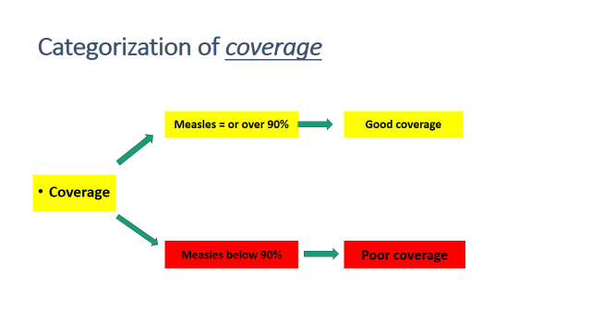

ACCESS
Possibility of the person reaching the intended place easily and getting service
Vaccination access: determined by 1st dose of Penta
Are they coming? Yes they will be vaccinated – access good
If not than they can not be vaccinated.
Why are they not coming?? Not accessible
Identify the reasons of not accessible
UTILIZATION
Continuation of using the services
Vaccination utilization: determined by Measles coverage
- Do they continue to use the services? Yes, drop out is low.
- If not than high drop out. They can not finish required doses.
- Why?? Not utilizing the services
- Identify the reasons of not utilizing services

CALCULATION
- Children vaccinated with 1st dose of Penta
- Children vaccinated with Measles

Penta 1 – Measles = Children who have dropped out from the service

- Drop out rate: multiply 100 (standardization)

Categorization of utilization

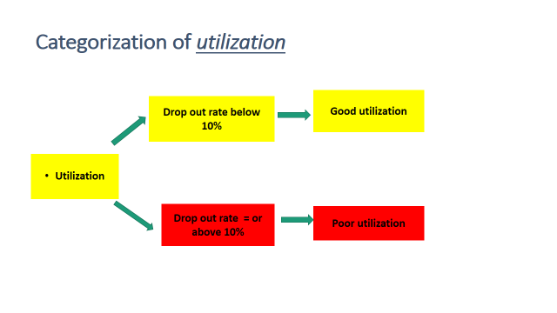
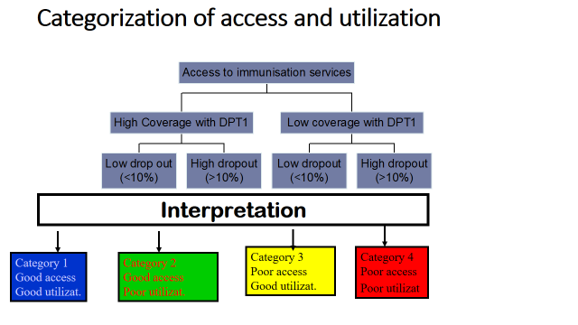

RED Activities at District level
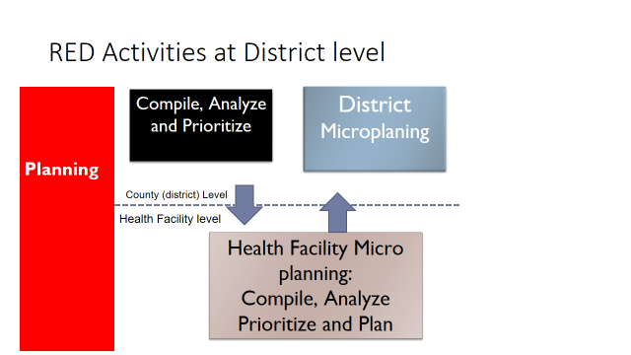

Reaching the Target Population

Where to focus
- Select the facilities which are contributing a big number of vaccinated children
- Avoid to over stretch the resources
- To be realistic - 10 facilities
- Experience shows 10 facilities contribute more than 50% of unvaccinated children
Way forward
- To build the capacity of the district to able to do this analysis
- Analysis need to be done regularly
- This process can be done frequently as the situation allows
- Prioritize the health facilities to focus

WHY ARE THEY NOT REACHED
Discuss with the facilities staff: Why are they not reached
Example:
- Distance from the health facility
- Shortage of vaccines
- Shortage of staff to vaccinate
- No outreach services
- Non compliance
- Too many children per session
- Hard to reach
WAY FORWARD
- All unvaccinated children must be reached
- Analysis of performance needs to be done regularly
- Build capacity of the district to be able to do this analysis
- Determine health facilities with large number of unvaccinated children and Prioritize the health facilities to focus
- Implement service delivery strategies that are appropriate to the needs of the populations;
- Be innovative.

References/ further reading
- MOH, Kenya (2015) Immunization Manual for health workers
- MOH, Kenya (2015) Immunization Manual for Medical Students and Nursing Students,
- WHO (2015) EPI Prototype Curriculum 2015 (NESI, USAID, UNICEF,GAVI)

